NAME-SURNAME:
NUMBER:
CLASS: 6/…..
2025-2026 EDUCATIONAL YEAR ……………………………………………….LOWER SECONDARY SCHOOL
2ND TERM 1ST LISTENING EXAM FOR 6TH GRADERS

PART A . Listen to the text and fill in the blanks. (5x……….=…….pts)

Hello! My name is Henry and I am a (1)……………………I work in a big company with many people. My friend, Mark, is an (2)……………………….. ; he can design buildings and draw amazing plans. He was in Istanbul last week for a new project. Our(3) ………………….., Mr. Brown, is very busy today. He can manage the whole office. We also have a mechanic named Sam; he can repair or (4)……………………..our office cars when they are broken. Yesterday, I wasn't at the office because I (5)…………………. ill. I went to the dentist. He can pull out teeth and help people. Now, I am back and I can prepare all the documents for my boss.

PART B . Listen to the text and fill in the blanks. (5x………..=……..pts)

Last summer, my family and I went on a great holiday. We didn't (1)……………….. at a hotel; we stayed in a tent in the forest. It was very exciting. In the mornings, my father and I(2)……………… hiking and climbed a mountain. My mother didn't climb with us; she stayed near the lake and fished. One day, we joined a boat tour and s(3)………….. in the blue water. I learned (4)…………….. there. My sister made a sandcastle on the beach and sunbathed all day. We (5)………………….. historical places and a museum too. We were very tired but very happy.

PART C. Listen to the text and tick the activities you hear (5x………..=……….pts)



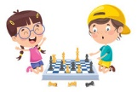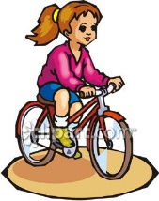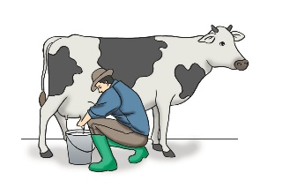

PART A . Listen to the text and fill in the blanks.

Hello! My name is Henry and I am a salesman. I work in a big company with many people. My friend, Mark, is an architect ; he can design buildings and draw amazing plans. He was in Istanbul last week for a new project. Our manager, Mr. Brown, is very busy today. He can manage the whole office. We also have a mechanic named Sam; he can repair or fix our office cars when they are broken. Yesterday, I wasn't at the office because I was ill. I went to the dentist. He can pull out teeth and help people. Now, I am back and I can prepare all the documents for my boss.

PART B . Listen to the text and fill in the blanks.

Last summer, my family and I went on a great holiday. We didn't stay at a hotel; we stayed in a tent in the forest. It was very exciting. In the mornings, my father and I went hiking and climbed a mountain. My mother didn't climb with us; she stayed near the lake and fished. One day, we joined a boat tour and swam in the blue water. I learned diving there. My sister made a sandcastle on the beach and sunbathed all day. We visited historical places and a museum too. We were very tired but very happy.

PART C. Listen to the text and tick the activities you hear
Two years ago, we visited my grandparents on their farm. It was winter and there was a lot of snow. We didn't go on a sightseeing tour, but we had a lot of fun. We played snowball and made a snowman in the garden. I milked the cows with my grandfather and watered the vegetables in the greenhouse. My grandmother cooked traditional food for us. In the evenings, we played chess and my brother played the guitar. We didn't watch a movie because we talked all night. It was the best winter holiday of my life.

